**Optimization of 3D printed beam in terms of Infill Density, Infill Pattern and Wall Thickness**

**Literature Survey**

In the video by YouTube Channel “3D Printer Academy” named “This 3D Printer infill is the strongest (3D Printer Academy Tested - Episode 2)” they go over the different factors for optimisation of the strength to weight ratio.

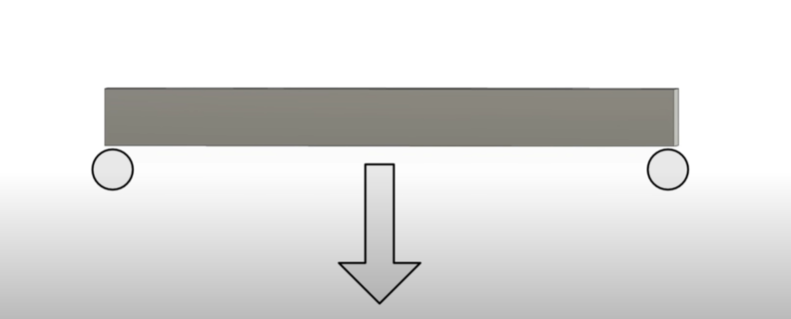

Figure Load bearing for the part and how it acts on the beam

Based on Number of Walls

This data illustrates the performance characteristics of 3D printed structures across varying wall thicknesses.

|  |  |  |  |  |  |  |  |  |
| --- | --- | --- | --- | --- | --- | --- | --- | --- |
| **Walls** | **Strength (kg) - Sunlu PLA+** | **Strength (kg) - BAMBU LAB PLA BASIC** | **Average Strength (kg)** | **Weight** | **Cost** | **Cost per 100kg** | **Kg/$** | **Strength/**  **Weight** |
| 1 | 53.8 | 53.2 | 53.5 | 24.71 | 0.62 | 1.15 | 87 | 2.2 |
| 2 | 74.2 | 62.1 | 68.15 | 27.73 | 0.69 | 0.93 | 108 | 2.5 |
| 3 | 88.4 | 72 | 80.2 | 30.3 | 0.76 | 0.86 | 116 | 2.6 |
| 4 | 103.3 | 85.6 | 94.45 | 32.85 | 0.82 | 0.79 | 126 | 2.9 |
| 5 | 118.2 | 93.9 | 106.05 | 35.43 | 0.89 | 0.75 | 133 | 3 |
| 6 | 129.9 | 106.9 | 118.4 | 38 | 0.95 | 0.73 | 137 | 3.1 |
| 7 | 143.1 | 116.3 | 129.7 | 40.89 | 1.02 | 0.71 | 140 | 3.2 |
| 8 | 158.7 | 128.3 | 143.5 | 44.01 | 1.1 | 0.69 | 144 | 3.3 |

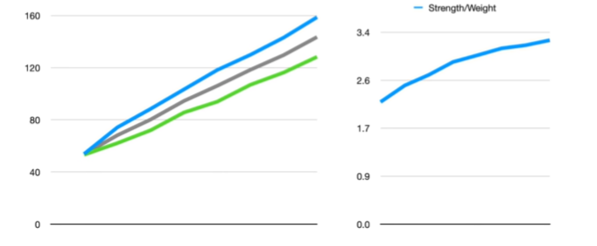

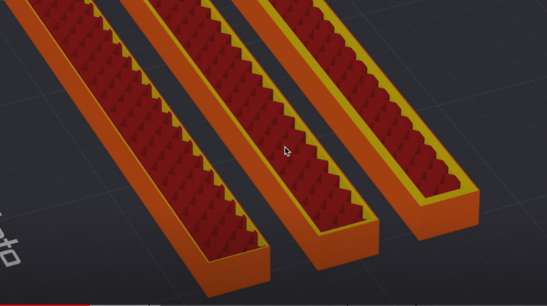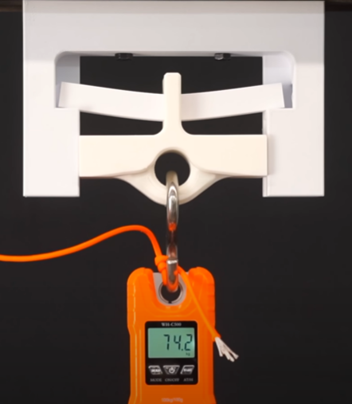The table compares two materials, Sunlu PLA+ and BAMBU LAB PLA BASIC, showing their strength properties alongside average strength, weight, cost metrics, and strength-to-weight ratios. As wall count increases from 1 to 8, there's a consistent upward trend in strength, weight, and cost. The strength values range from 53.5 kg for a single wall to 143.5 kg for eight walls, with corresponding increases in weight from 24.71 kg to 44.01 kg. Cost efficiency, represented by kg/$, also improves with wall count, rising from 87 to 144. The strength-to-weight ratio demonstrates steady improvement, starting at 2.2 and reaching 3.3 for the thickest configuration.

Accompanying graphs visually reinforce these trends, with one chart displaying the parallel growth of key metrics and another focusing on the strength-to-weight ratio progression. This comprehensive overview provides valuable insights for optimizing 3D printing parameters based on desired strength, weight, and cost considerations.

Based on the Infill Density

This image presents a table from 3D Printer Academy (2024) showing the relationship between infill percentage and various 3D printing metrics.

|  |  |  |  |  |
| --- | --- | --- | --- | --- |
| **Infill %** | **Strength (kg)** | **Weight** | **Cost** | **Strength/Weight** |
| 0% | 43.5 | 15.14 | 0.38 | 2.9 |
| 10% | 80.2 | 23.67 | 0.59 | 3.4 |
| 20% | 79.1 | 30.79 | 0.77 | 2.6 |
| 30% | 94.7 | 37.44 | 0.94 | 2.5 |
| 40% | 108.2 | 45.76 | 1.14 | 2.4 |
| 50% | 113.5 | 52.33 | 1.31 | 2.2 |
| 60% | 129.9 | 59.19 | 1.48 | 2.2 |
| 70% | 141 | 67.55 | 1.69 | 2.1 |
| 80% | 142.8 | 73.97 | 1.85 | 1.9 |

The table displays data for infill percentages ranging from 0% to 80% in 10% increments. It includes columns for Strength (kg), Weight, Cost, and Strength/Weight ratio. As the infill percentage increases, there's a general trend of increasing strength, weight, and cost. The strength ranges from 43.5 kg at 0% infill to 142.8 kg at 80% infill. Weight increases from 15.14 units at 0% to 73.97 units at 80%, while cost rises from 0.38 to 1.85 units. Interestingly, the Strength/Weight ratio doesn't follow a linear trend. It peaks at 3.4 with 10% infill, then generally decreases as infill percentage increases, reaching 1.9 at 80% infill. This data suggests that while higher infill percentages provide greater strength, they come at the cost of increased weight and material usage. The optimal infill percentage would depend on the specific requirements of the printed object, balancing strength, weight, and cost considerations.

Comparison of the Number of Walls and Infill Density

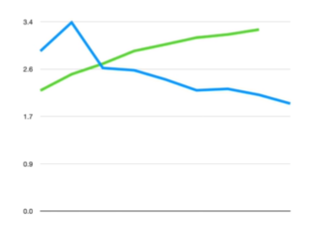Based on both the tables for Infill Density and Number of Walls for the strength to weight ratio, the intersecting point on both the lines is the point for most optimum Value when comparing Walls and Infill Density. Which would be 3 Walls and 20% Infill density.

Infill Pattern

The data presented outlines the strength, weight, and strength-to-weight ratios of various 3D printed geometries, providing valuable insights into their structural performance. The table below summarizes the key metrics for each design:

|  |  |  |  |
| --- | --- | --- | --- |
| **Name** | **Strength** | **Weight** | **Strength/Weight** |
| Octagram Spiral | 61.7 | 22.4 | 2.75 |
| Archimedean Chords | 63.4 | 22.4 | 2.83 |
| Tri-hexagon | 68.4 | 21.71 | 3.15 |
| Hilbert Curve | 70.9 | 22.31 | 3.18 |
| Aligned Rectilinear | 73.6 | 22.47 | 3.28 |
| Support Cubic | 65.3 | 19.24 | 3.39 |
| Triangles | 79.1 | 21.91 | 3.61 |
| Honeycomb | 88.1 | 24.4 | 3.61 |
| Line | 81.3 | 22.38 | 3.63 |
| Concentric | 85.1 | 23.36 | 3.64 |
| Rectilinear | 82 | 22.47 | 3.65 |
| Grid | 79.8 | 21.69 | 3.68 |
| Cubic | 83.6 | 21.88 | 3.82 |
| Adaptive Cubic | 76.1 | 19.48 | 3.91 |
| 3D Honeycomb | 91.1 | 23.11 | 3.94 |
| Gyroid | 87.4 | 21.39 | 4.09 |
| Lightning | 61.2 | 14.69 | 4.17 |

The data shows that as the strength of the geometries increases, there is a corresponding variation in weight.

The Lightning design achieves the highest strength-to-weight ratio of 4.17, despite having a lower overall strength. This indicates that designs where most of the stress falls on the wall thickness affects the overall ratio.

Structures like the Gyroid and 3D Honeycomb demonstrate effective use of material, achieving high strength-to-weight ratios (4.09 and 3.94, respectively) while remaining relatively lightweight. The findings suggest that geometric configurations significantly influence the mechanical properties of 3D printed objects.

Designs that incorporate hollow or lattice structures, such as honeycomb patterns, are effective in maximizing strength while minimizing weight.

**Compressive Strength Testing on Different Infill Patterns**

The video “Which Infill Pattern is the STRONGEST? | 3D Printing Testing Lab” by “Slant 3D” tests different infill patterns in 3D printing to determine their strength under compression forces.

Patterns such as grid, triangle, stars, lines, cubic, honeycomb, Rec linear, and gyroid are compared for their performance. The cubic infill pattern is found to be the strongest overall, but other factors like air flow and functionality also need to be considered when choosing an infill pattern for printing parts.

|  |  |
| --- | --- |
| Pattern | Ultimate Compressive Strength (N) |
| Grid | 902 |
| Triangles | 818 |
| Stars | 806 |
| Lines | 1206 |
| Cubic | 2006 |
| Honeycomb | 1900 |
| Rectilinear | 1074 |
| Gyroid | 1474 |

- Grid: Collapses almost completely.  
- Triangle: Immediate failure with continuous crushing.  
- Stars: Catastrophic failure immediately upon applying force.  
- Lines: A unique infill pattern with a suspension-like quality inside the part, crushes continuously with slight shear failure.  
- Cubic: Very rigid and uniform in both XY and Z directions, crushes continuously without core failure.  
- Honeycomb: Diagonal failure at first, compresses without full separation or shear, stair-stepping strength as cells stack up.  
- Rec linear: Similar to lines and grid, crushes with failure along the diagonal.  
- Gyroid: Crushes reliably without catastrophic failure, though not universally stronger than standard patterns.

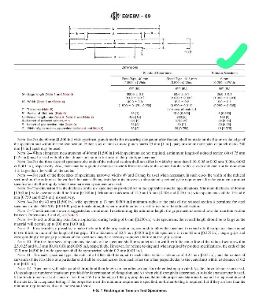**Test 1**

A Consecutive Analysis on Strength of 3D Printed Parts based on the infill percentage, Infill Shape, Wall thickness, and other factors and optimization for these parts.

Research on Analysis of Strength of 3D printed parts.

Test 1

Tensile Testing

For conducting the actual test, we need to conduct a general test for the procedure to understand the types of issues we might have.

We designed the specimen for

|  |  |  |  |  |  |
| --- | --- | --- | --- | --- | --- |
| S.No | Type | Number of Walls | Infill Density | Infill Shape | Print Type |
| 1 | Subsize Specimen | 3 | 20% | Hexagonal | Layed Flat |
| 2 | Subsize Specimen | 3 | 20% | Hexagonal | Standing |
| 3 | Subsize Specimen | 1 | 10% | Grid | Layed Flat |
| 4 | Subsize Specimen | 1 | 10% | Grid | Standing |

Compressive Testing

10 x 10 x 10 mm and 30 x 30 x 30 mm cubes to be printed.

|  |  |  |  |  |  |
| --- | --- | --- | --- | --- | --- |
| S.No | Type | Number of Walls | Infill Density | Infill Shape | Print Type |
| 1 | Cube | 3 | 20% | Hexagonal | Layed Flat |
| 2 | Cube 30 size | 3 | 20% | Hexagonal | Layed Flat |
| 3 | Cube | 3 | 20% | Hexagonal | Standing |
| 4 | Cube 30 size | 3 | 20% | Hexagonal | Standing |
| 5 | Cube | 1 | 10% | Grid | Layed Flat |
| 6 | Cube 30 size | 1 | 10% | Grid | Layed Flat |

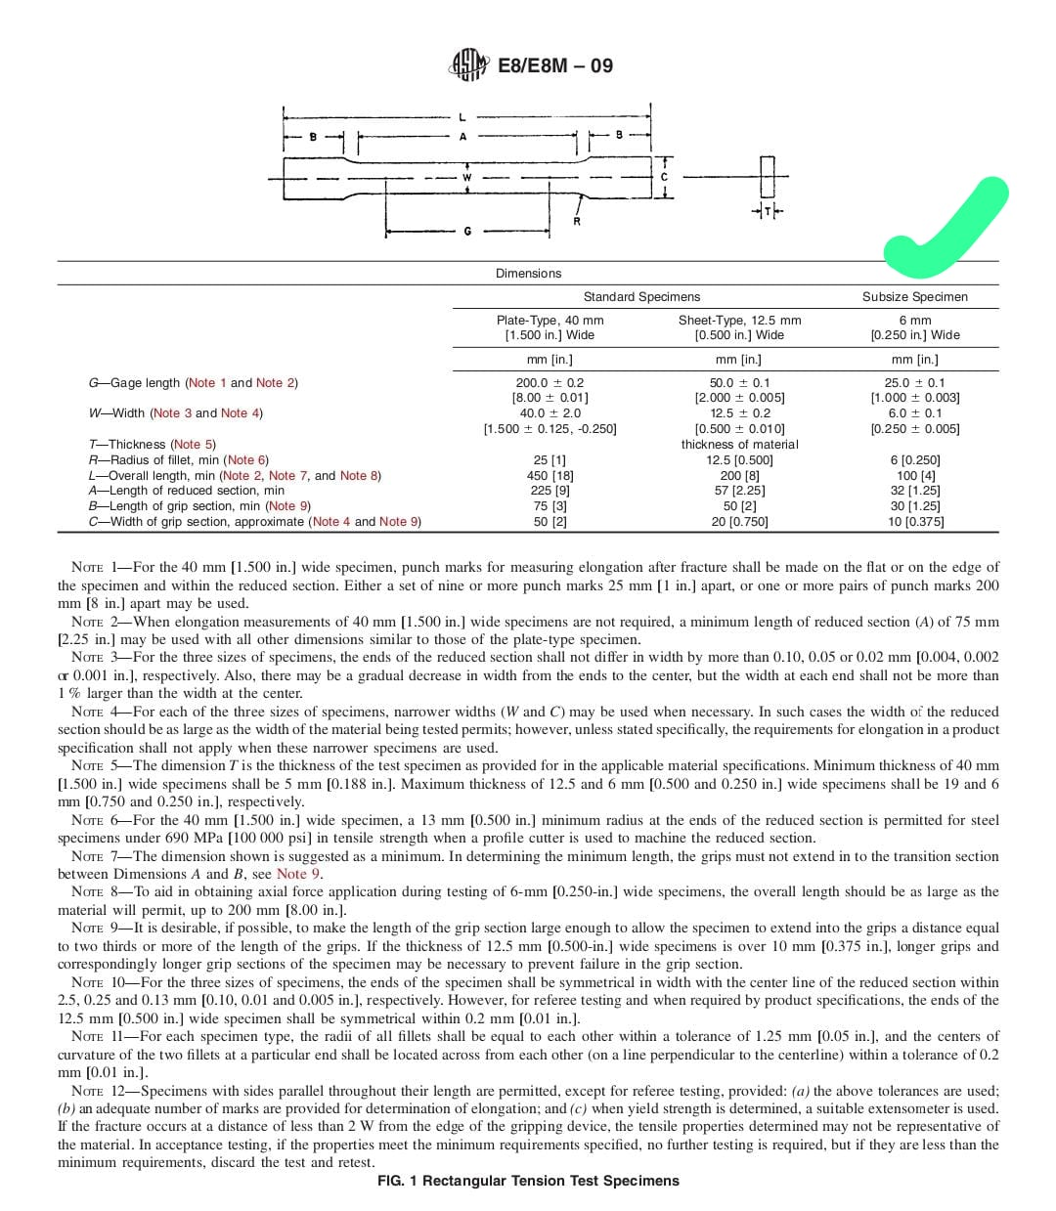

For conducting tensile and compressive testing, the goal is to gain insight into potential issues that may arise during the actual testing procedure. Below is a summary of the preparation and setup for both tests.

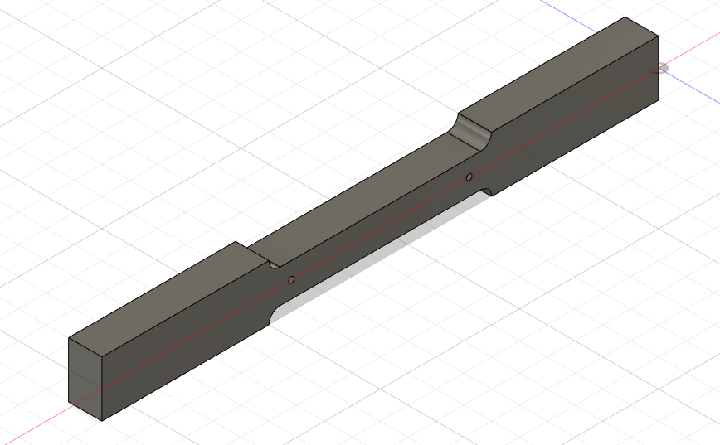**Tensile Testing:** In the tensile test, subsize specimens are printed and prepared under various configurations to examine how different infill patterns, densities, and orientations affect the mechanical properties of the printed material.

This setup aims to compare the mechanical performance of the specimens based on orientation (laid flat vs. standing), number of walls, infill density, and infill shape.

* **Factors to Study:**
  + Tensile strength variation between flat and standing specimens.
  + Impact of infill density (20% vs. 10%) on overall tensile behaviour.
  + 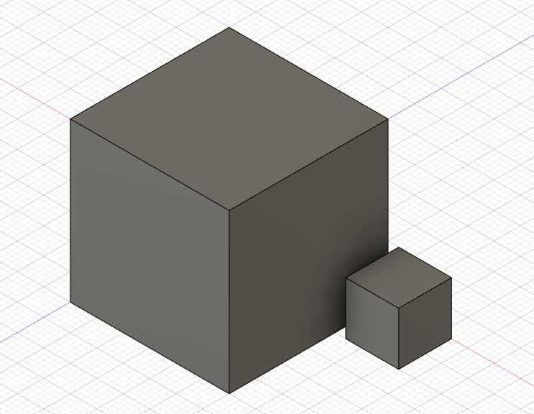Effects of different infill shapes (Hexagonal vs. Grid) on specimen rigidity and failure mode.

**Compressive Testing:** For compressive testing, two different cube sizes are prepared: 10 x 10 x 10 mm and 30 x 30 x 30 mm. Similar to the tensile test, variations in the number of walls, infill density, infill shape, and print type are used to understand the impact of these parameters under compression.

This setup is designed to observe how cube size, infill density, infill shape, and print orientation influence compressive strength.

* **Factors to Study:**
  + The relationship between infill shape (Hexagonal vs. Grid) and compressive failure patterns.
  + The effect of specimen size on compressive strength.
  + Comparison of standing and laid-flat orientations under compression to analyze stability.

**Test 2**

**Tensile Test**

Infill Density

|  |  |  |  |  |
| --- | --- | --- | --- | --- |
| S.No | Type | Number of Walls | Infill Density | Infill Shape |
| 1 | Subsize Specimen | 1 | 10% | Grid |
| 2 | Subsize Specimen | 1 | 20% | Grid |
| 3 | Subsize Specimen | 1 | 30% | Grid |
| 4 | Subsize Specimen | 1 | 40% | Grid |
| 5 | Subsize Specimen | 1 | 50% | Grid |
| 6 | Subsize Specimen | 1 | 60% | Grid |
| 7 | Subsize Specimen | 1 | 70% | Grid |
| 8 | Subsize Specimen | 1 | 80% | Grid |

It includes columns for Strength (kg), Weight, Cost, and Strength/Weight ratio. As the infill percentage increases, there's a general trend of increasing strength, weight, and cost. For test conducted the values were based on this table.

|  |  |  |  |  |
| --- | --- | --- | --- | --- |
| Infill Percentage | Strength | Weight | Cost | Strength/Weight |
| 10% |  |  |  |  |
| 20% |  |  |  |  |
| 30% |  |  |  |  |
| 40% |  |  |  |  |
| 50% |  |  |  |  |
| 60% |  |  |  |  |
| 70% |  |  |  |  |
| 80% |  |  |  |  |

Wall Thickness

|  |  |  |  |  |
| --- | --- | --- | --- | --- |
| S.No | Type | Number of Walls | Wall Number | Infill Shape |
| 1 | Subsize Specimen | 20% | 1 | Grid |
| 2 | Subsize Specimen | 20% | 2 | Grid |
| 3 | Subsize Specimen | 20% | 3 | Grid |
| 4 | Subsize Specimen | 20% | 4 | Grid |
| 5 | Subsize Specimen | 20% | 5 | Grid |
| 6 | Subsize Specimen | 20% | 6 | Grid |
| 7 | Subsize Specimen | 20% | 7 | Grid |
| 8 | Subsize Specimen | 20% | 8 | Grid |

It includes columns for Strength (kg), Weight, Cost, and Strength/Weight ratio. As the infill percentage increases, there's a general trend of increasing strength, weight, and cost. For test conducted the values were based on this table.

|  |  |  |  |  |
| --- | --- | --- | --- | --- |
| Wall Number | Strength | Weight | Cost | Strength/Weight |
| 1 |  |  |  |  |
| 2 |  |  |  |  |
| 3 |  |  |  |  |
| 4 |  |  |  |  |
| 5 |  |  |  |  |
| 6 |  |  |  |  |
| 7 |  |  |  |  |
| 8 |  |  |  |  |

Infill Shape

|  |  |  |  |  |
| --- | --- | --- | --- | --- |
| S.No | Type | Number of Walls | Wall Number | Infill Shape |
| 1 | Subsize Specimen |  |  | Grid |
| 2 | Subsize Specimen |  |  |  |
| 3 | Subsize Specimen |  |  |  |
| 4 | Subsize Specimen |  |  |  |
| 5 | Subsize Specimen |  |  |  |
| 6 | Subsize Specimen |  |  |  |
| 7 | Subsize Specimen |  |  |  |
| 8 | Subsize Specimen |  |  |  |

It includes columns for Strength (kg), Weight, Cost, and Strength/Weight ratio. As the infill percentage increases, there's a general trend of increasing strength, weight, and cost. For test conducted the values were based on this table.

|  |  |  |  |  |
| --- | --- | --- | --- | --- |
| Infill Shape | Strength | Weight | Cost | Strength/Weight |
|  |  |  |  |  |
|  |  |  |  |  |
|  |  |  |  |  |
|  |  |  |  |  |
|  |  |  |  |  |
|  |  |  |  |  |
|  |  |  |  |  |
|  |  |  |  |  |

**Compressive Test**

Infill Density

|  |  |  |  |  |
| --- | --- | --- | --- | --- |
| S.No | Type | Number of Walls | Infill Density | Infill Shape |
| 1 | Cube | 1 | 10% | Grid |
| 2 | Cube | 1 | 20% | Grid |
| 3 | Cube | 1 | 30% | Grid |
| 4 | Cube | 1 | 40% | Grid |
| 5 | Cube | 1 | 50% | Grid |
| 6 | Cube | 1 | 60% | Grid |
| 7 | Cube | 1 | 70% | Grid |
| 8 | Cube | 1 | 80% | Grid |

It includes columns for Strength (kg), Weight, Cost, and Strength/Weight ratio. As the infill percentage increases, there's a general trend of increasing strength, weight, and cost. For test conducted the values were based on this table.

|  |  |  |  |  |
| --- | --- | --- | --- | --- |
| Infill Percentage | Strength | Weight | Cost | Strength/Weight |
| 10% |  |  |  |  |
| 20% |  |  |  |  |
| 30% |  |  |  |  |
| 40% |  |  |  |  |
| 50% |  |  |  |  |
| 60% |  |  |  |  |
| 70% |  |  |  |  |
| 80% |  |  |  |  |

Wall Thickness

|  |  |  |  |  |
| --- | --- | --- | --- | --- |
| S.No | Type | Number of Walls | Wall Number | Infill Shape |
| 1 | Cube | 20% | 1 | Grid |
| 2 | Cube | 20% | 2 | Grid |
| 3 | Cube | 20% | 3 | Grid |
| 4 | Cube | 20% | 4 | Grid |
| 5 | Cube | 20% | 5 | Grid |
| 6 | Cube | 20% | 6 | Grid |
| 7 | Cube | 20% | 7 | Grid |
| 8 | Cube | 20% | 8 | Grid |

It includes columns for Strength (kg), Weight, Cost, and Strength/Weight ratio. As the infill percentage increases, there's a general trend of increasing strength, weight, and cost. For test conducted the values were based on this table.

|  |  |  |  |  |
| --- | --- | --- | --- | --- |
| Wall Number | Strength | Weight | Cost | Strength/Weight |
| 1 |  |  |  |  |
| 2 |  |  |  |  |
| 3 |  |  |  |  |
| 4 |  |  |  |  |
| 5 |  |  |  |  |
| 6 |  |  |  |  |
| 7 |  |  |  |  |
| 8 |  |  |  |  |

Infill Shape

|  |  |  |  |  |
| --- | --- | --- | --- | --- |
| S.No | Type | Number of Walls | Wall Number | Infill Shape |
| 1 | Cube |  |  | Grid |
| 2 | Cube |  |  |  |
| 3 | Cube |  |  |  |
| 4 | Cube |  |  |  |
| 5 | Cube |  |  |  |
| 6 | Cube |  |  |  |
| 7 | Cube |  |  |  |
| 8 | Cube |  |  |  |

It includes columns for Strength (kg), Weight, Cost, and Strength/Weight ratio. As the infill percentage increases, there's a general trend of increasing strength, weight, and cost. For test conducted the values were based on this table.

|  |  |  |  |  |
| --- | --- | --- | --- | --- |
| Infill Shape | Strength | Weight | Cost | Strength/Weight |
|  |  |  |  |  |
|  |  |  |  |  |
|  |  |  |  |  |
|  |  |  |  |  |
|  |  |  |  |  |
|  |  |  |  |  |
|  |  |  |  |  |
|  |  |  |  |  |

For conducting tensile and compressive testing, the goal is to gain insight into potential issues that may arise during the actual testing procedure. Below is a summary of the preparation and setup for both tests.

**Tensile Testing:** In the tensile test, subsize specimens are printed and prepared under various configurations to examine how different infill patterns, densities, and orientations affect the mechanical properties of the printed material.

This setup aims to compare the mechanical performance of the specimens based on orientation (laid flat vs. standing), number of walls, infill density, and infill shape.

* **Factors to Study:**
  + Tensile strength variation between flat and standing specimens.
  + Impact of infill density (20% vs. 10%) on overall tensile behaviour.
  + Effects of different infill shapes (Hexagonal vs. Grid) on specimen rigidity and failure mode.

**Compressive Testing:** For compressive testing, two different cube sizes are prepared: 10 x 10 x 10 mm and 30 x 30 x 30 mm. Similar to the tensile test, variations in the number of walls, infill density, infill shape, and print type are used to understand the impact of these parameters under compression.

This setup is designed to observe how cube size, infill density, infill shape, and print orientation influence compressive strength.

* **Factors to Study:**
  + The relationship between infill shape (Hexagonal vs. Grid) and compressive failure patterns.
  + The effect of specimen size on compressive strength.
  + Comparison of standing and laid-flat orientations under compression to analyze stability.